Images SI Stepper Motor Controller Datasheet

Features
- General / Hobby Purpose Stepper Motor Controller.
- Compatible with 4 Phase Unipolar / 2 Phase Bipolar Motors.
- Master / Slave mode – Standalone Free Running Controller in Master Mode.
- 8 RPM Selections in Free Running Mode.
- Compatible with variety of Drivers - L298, L293, Darlington Arrays, Discrete Transistors.
- Half / Full (Wave Drive – 1 Phase & 2 Phase Drives) Step Modes, Direction Control, Enable – Reset inputs, Home output.
- Power On Reset initializes controller

Pinout
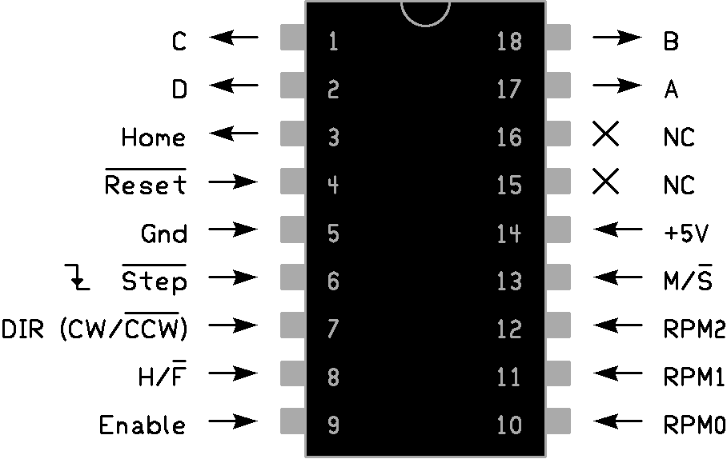
Pin Description
All inputs / outputs are TTL compatible.
Pin | Name | Description
17, 18, 1, 2 | A, B, C, D | Output Winding Control signals.
3 | Home | Home output signal (ABCD = 0101).
4 | Reset | Active Low Reset input.
15, 16 | NC, NC | No Connect, leave them floating.
6 | Step | Step Clock input.
7 | DIR | Direction selection (CW / CCW) input.
8 | H/F | Half / Full Step mode selection input.
9 | Enable | Enable input.
13 | M/S | Master (Free Running) / Slave mode selection input.
10, 11, 12 | RPM0, RPM1, RPM2 | RPM selection inputs.

RPM Selection Table
In Master – Free Running mode, chip acts as Standalone Controller, with Step Clock being generated internally.
8 Different RPMs can be selected by different combinations on 3 – bit Binary input pins RPM2, RPM1, RPM0. RPM2 is MSB & RPM0 is LSB.
Gray Encoded inputs ensure that only one input needs to be change state at a time to switch between consecutive RPM settings.
RPM calculations are made for 1.8 degrees / step, 200 steps per revolution Motors. For different degrees / step ratings of Motors, RPM will be different.
RPM figures are approximate & shouldn’t be considered for highly accurate operations, although will easily suffice accuracy for general & hobby purpose Stepper Motor applications.
Period till 1st Cycle of internally generated clock (i,e 1st Step of Stepper Motor) will be random with worst case period of 260 msecs, everytime when Master Mode is selected or when Enable is brought to high state in Master Mode.
RPM2 | RPM1 | RPM0 | RPM Selected
0 | 0 | 0 | 1
0 | 0 | 1 | 2
0 | 1 | 1 | 5
0 | 1 | 0 | 10
1 | 1 | 0 | 20
1 | 1 | 1 | 50
1 | 0 | 1 | 100
1 | 0 | 0 | 150

Winding Control Signals Chart
Stepper Motor cycles through States 1-2-3-4-5-6-7-8-1 in Half Step / Clockwise mode, & 1-8-7-6-5-4-3-2-1 in Half Step / Counter Clockwise mode.
Stepper Motor cycles through States 1-3-5-7-1 in Full Step 2 Phase Drive / Clockwise mode, & 1-7-5-3-1 in Full Step 2 Phase Drive / Counter Clockwise mode.
Stepper Motor cycles through States 2-4-6-8-2 in Full Step 1 Phase Wave Drive / Clockwise mode, & 2-8-6-4-2 in Full Step 1 Phase Wave Drive / Counter Clockwise mode.
A | B | C | D | Home | State Number
0 | 1 | 0 | 1 | 1 | 1
0 | 0 | 0 | 1 | 0 | 2
1 | 0 | 0 | 1 | 0 | 3
1 | 0 | 0 | 0 | 0 | 4
1 | 0 | 1 | 0 | 0 | 5
0 | 0 | 1 | 0 | 0 | 6
0 | 1 | 1 | 0 | 0 | 7
0 | 1 | 0 | 0 | 0 | 8
Functional Description
Images SI Stepper Motor Controller is a single chip Stepper Motor Controller with Standalone Free Running Control capability intended for General / Hobby purpose Stepper Motor Applications. Technically it is a sequencer / translator that generates Winding Control Signals for Stepper Motors & reduces programming burden on host microcontroller.
Images SI Stepper Motor Controller generates Winding Control Signals that can be used with for both Unipolar & Bipolar Stepper Motors with appropriate Winding Drivers. L298 & L293 can be used as Winding Drivers taking input from this controller & can driver both Unipolar / Bipolar Motors. Darlington Arrays / Discrete Transistors can also be used as Winding Drivers for Unipolar Motors.
Master / Slave input selects between Master (Standalone Free Running) or Slave (externally controlled) controller mode. High input selects Master mode, Low input selects slave mode. In Master mode, Stepper Motor advances automatically by internally generated clock cycles.
In Host Control (external control – slave mode) Stepper Motor advances next step on falling edge of external clock signal at Step input. The direction & angle of step motion depends on status of DIR & H/F inputs. These inputs are sampled at falling edge of external Clock edge.
Enable input is used to enable / disable controller. A low signal at enable input will disable the controller, bring output ABCD to 0000 & halts the internal sequencer from advancing to the next step, even if Step clock input is active during that time. This situation is particularly helpful in de-energizing motor windings in idle state / system initialization. When Enable input is brought back to high again, ABCD output will go to last state before Enable input was brought low. Enable input is active in both Master / Slave modes & is asynchronous of Step clock.
Reset input resets the controller & brings it to home position (ABCD = 0101). Reset is active low input & is active in both Master / Slave modes. Outputs are held in high impedance state till external Reset is present, all inputs will be ignored. After External Reset, Controller initialization will commence, which will last for 500 u sec. During Controller Initialization, all Outputs will be held to logic 0, all inputs except will be ignored. After Controller Initialization, Outputs will switch to Home State. Controller is then ready for normal Operation.
A, B, C, D are output Winding Control signals that can be connected to inputs of L298, L293, Darlington Arrays, Discrete Transistor for Winding Drives as per user requirements.
Home output signals the home state of Stepper Motor (ABCD = 0101). Whenever Stepper Motor is in home state, this output will be high. Home output stays high even if Enable is asserted low when Stepper Motor is in home state. Since there is no Home State in Full Step 2 Phase Wave Drive, Home output never goes high. Home output is active in both Master / Slave modes.
Internal Power On Reset will initialize the controller automatically on Power On, will place output ABCD = 0101 (State 1 – Home Position) & Home Output to a logic 1. Power On Reset will last for 72 m sec, provided Reset input is at logic 1. During this time outputs will be held in high impedance state, inputs will be ignored. After Power On Reset, Controller initialization will commence, which will last for 500 u sec. During Controller Initialization, all Outputs will be held to logic 0, all inputs except Reset will be ignored. After Controller Initialization, Outputs will switch to Home State. Controller is then ready for normal Operation.
Step Clock input is used to provide external Step Clock in Slave mode. Stepper Motor advances to next step on falling edge of this clock input. Step Clock Input is only active in Slave Mode.
Direction input selects the direction (Clockwise / Counter Clockwise) of motion. High input results in Clockwise step of Stepper Motor on next falling edge of external Step Clock input / internally generated clock cycle in Free Running Mode. Low input results in Counter Clockwise motion. Direction input is active for both Master / Slave modes. Actual Stepper Motor motion direction is relative & also depends on the way Motor Windings are connected to Winding Drivers.
Half / Full Step Mode selection input selects Half / Full Step Motions. High input selects Half Step Mode. Low input selects Full Step Mode. Full Step Mode supports both 1 Phase Wave Drive & 2 Phase Drive. Current state of Stepper Motor decides between 1 / 2 Phase Drive in Full Step Mode, when this input is asserted low.
For example, if current state of Stepper Motor is 0101 i,e 2 Phase Drive. Now if H/F input is made low, Stepper Motor will advance to 1001 state instead of 0001 on next falling edge of external Step Clock in Slave Mode or next internally generated clock cycle in Free Running Mode.
If current state of Stepper Motor is 0001 i,e 1 Phase Drive & H/F input is made low, Stepper Motor will advance to 1000 state instead of 1001 on next falling edge of external Step Clock in Slave Mode or next internally generated clock cycle in Free Running Mode.
Needless to say, H/F input is active in both Master / Slave modes.
RPM selection inputs selects 8 different RPM for Stepper Motor motion in Master Mode. These inputs are Gray Encoded, so only one of three inputs is required to change to switch between consecutive RPM settings.
0.1uF Bypass Capacitor should be connected between +5V & Gnd pins, as close to chip as possible.
A, B, C, D output signals should be connected with pull down resistors, to ensure stability power on / power off periods.
Its better practice to keep separate power supplies for Motor Power of Windings & Logic Power of Controller.

Specifications
Timing Specifications are for reference only, performance is not guaranteed.
- Supply Voltage range is +4 to +5.5 V.
- Minimum Supply Voltage Rise time 0.05 V / m sec to ensure Power On Reset.
- Time for Internal Power On Reset is 72 m sec.
- Time for Controller Initialization to commence after External Reset is 10 u sec.
- Controller Initialization Period after Power On Internal Reset / External Reset is 500 u sec.
- Output Rise & Fall time is 40 n sec.
- Minimum low pulse width on Reset Input is 2 u sec.
- Time for Outputs to go to High Impedance after Reset is brought low is 2.1u sec.
- Time for Outputs to go to logic 0 after External Reset is 10 u sec.
- Minimum Pulse Width (high or low) on Step Clock input is 0.5 u sec.
- Worst Case Propagation Delay for Enable Input is 40 u sec.
- Minimum Enable Pulse Width (high or low) is 40 u sec.
- Setup Time required for inputs H/F & DIR with respect to falling edge of Step Clock input is 0.
- Hold Time required for inputs H/F & DIR with respect to falling edge of Step Clock is 50 u sec.
- Propagation Delay for Outputs to change after falling edge of Step Clock is 50 u sec.
Important Note
Industrial Stepper Motor controllers available commercially consists of combinational & sequential logic, which have fast responses (propagation delays in terms of nano seconds) & lower hold time requirements. Images SI Stepper Motor Controller is a stored program control unit, meant for General / Hobby purpose applications. So expecting time responses similar to those of Industrial Devices is not advised. Best time to change the synchronous inputs (H/F, DIR) are when Step Clock input is high & preferable Step Clock Duty cycle is 50%. This will ensure best possible results.

