Images SI Stepper Motor Controller Application Circuits

2 Phase Bipolar Stepper Motor – Slave Mode
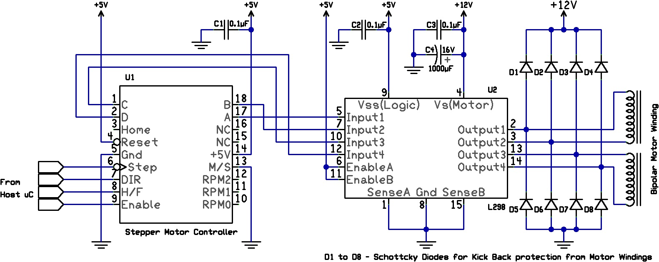
4 Phase Unipolar Stepper Motor – Slave Mode
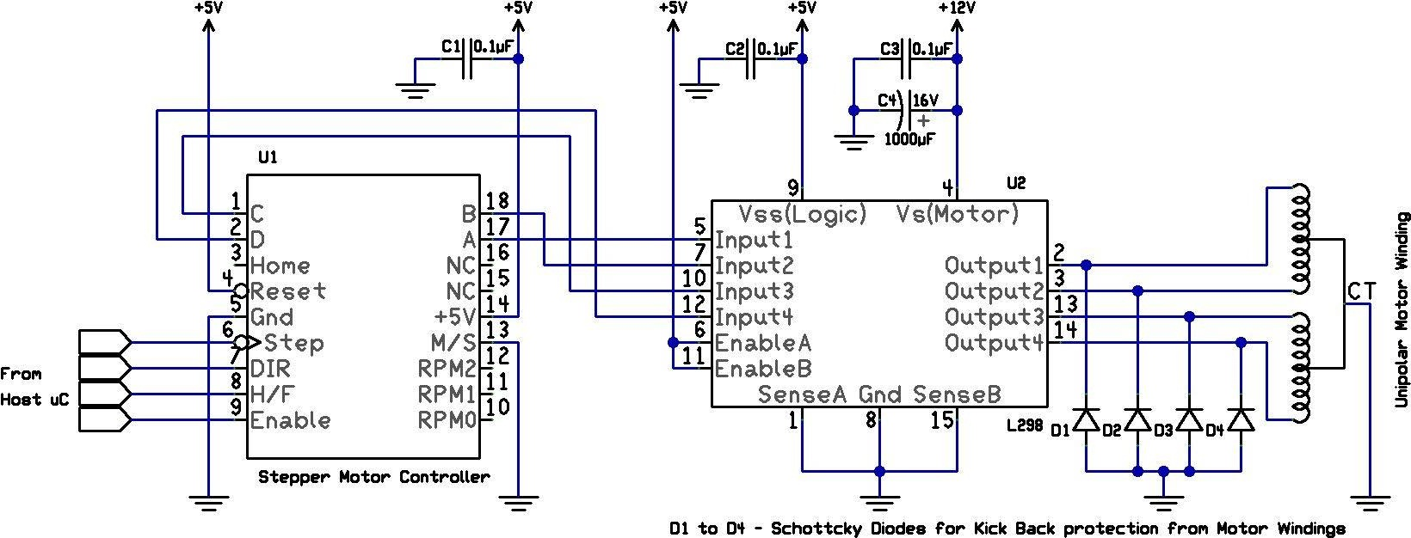

M/S input (Pin 13) of U1 is grounded for slave operation of Stepper Controller, to be controlled by external Host Microcontroller. Step Clock, Direction, Half / Full Step & Enable signals are provided from external system.
Pins 12, 11, 10 (RPM2 : RPM1 : RPM0) are left floating, since they are ignored in Slave mode.
Reset input is tied to +5V, it may also be an external signal coming in from Host Microcontroller. Power On reset will initialize Stepper Controller on Power Up.
Pins 15, 16 are NC & left floating.
L298 (U2) Dual Full H Bridge driver is used to drive Motor Windings. Winding Control Signals out of Stepper Motor Controller A, B, C, D are connected directly to Bridge inputs (Input 1 to Input 4) of L298. Pull Down resistors should be used on each of 4 inputs of L298 for stability during Power On & Power Off Periods, which are not shown here.
Enable inputs of L298 are permanently tied to +5V lines, which allows exclusive control of H Bridges to Input1 to Input4.
Notice that the only difference between Bipolar & Unipolar Motor Connection is CT (Center Tap) connection(s) of Unipolar Motor is grounded (instead of conventionally being connected to positive supply voltage).
A 5 Wire Unipolar Motor will have one CT connection, while a 6 Wire Unipolar Motor will have two CT connections. All CT connections of Unipolar Motor are required to be grounded.
Only 4 External Diodes are necessary in Unipolar Motor connection at output of L298.
Motor Motion Direction is not absolutely dependent on input pin DIR, but will also depend on how Motor Windings are connected to outputs of Bridge Drivers.
Similarly L293 can be used & provide a single circuit solution for both Unipolar & Bipolar Motors.

4 Phase Unipolar Motor – Master (Free Running) mode
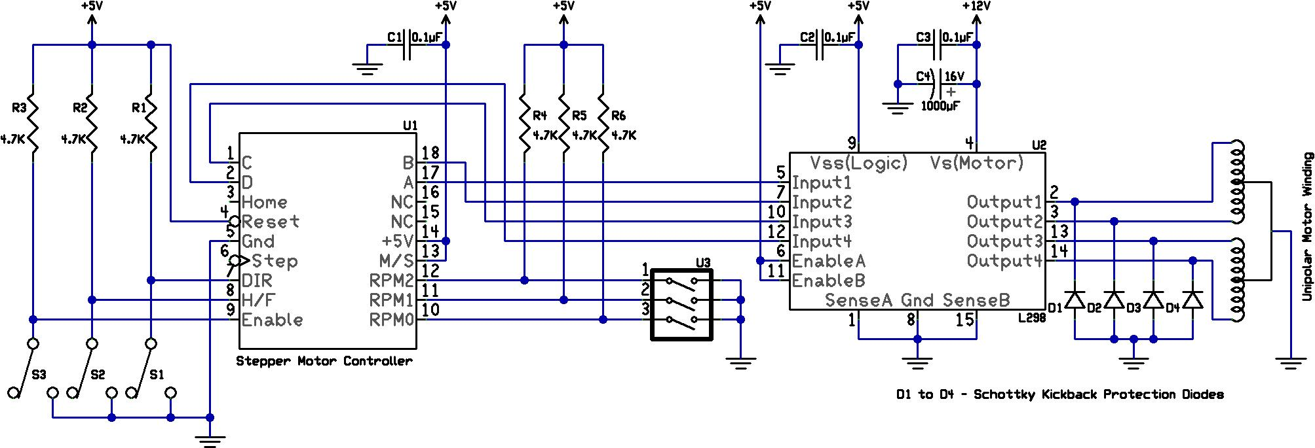
M/S input is tied to +5V for Master – Free Running operation. 3 Position DIP Switch – U3 controls Stepper Motor RPM. Stepper Motor motion is dependent on state of switches S1, S2 & S3 connected to DIR, H/F, Enable inputs.
Pull down resistors on A, B, C, D outputs are not shown.

